Square-Base Pyramid
# Source: AI Source: Provided by: [Data Path: Persons Table -> ID Column: 1, Name_En Column: Motasem Essam] -> From: [ChatGPT] on [7/25/2026]
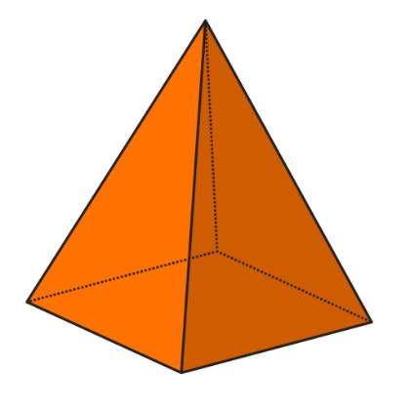
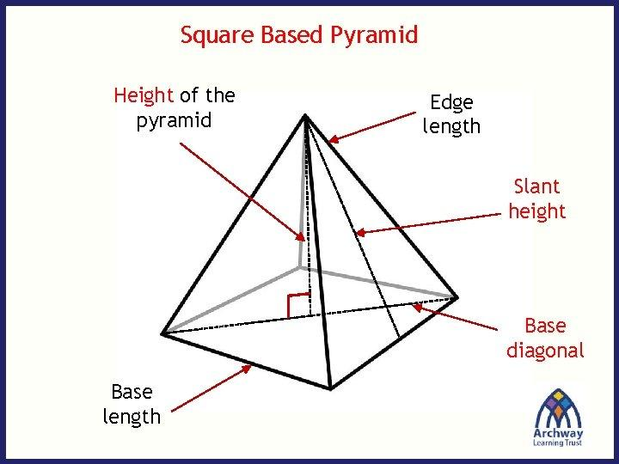
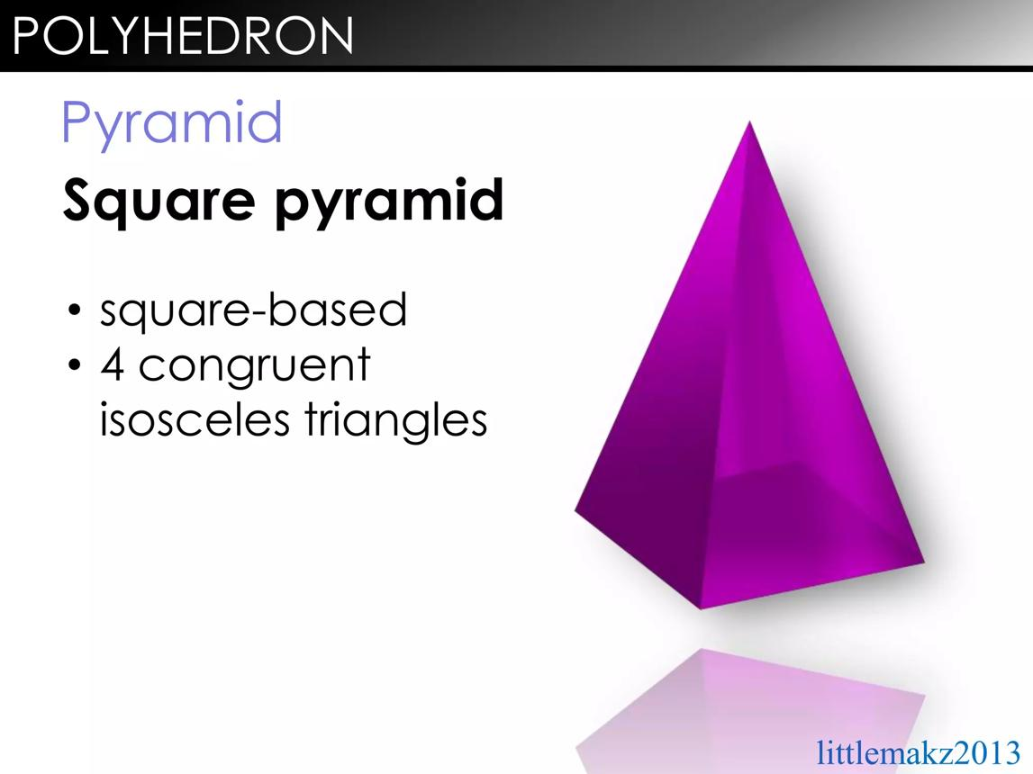

Definition
# Source: AI Source: Provided by: [Data Path: Persons Table -> ID Column: 1, Name_En Column: Motasem Essam] -> From: [ChatGPT] on [7/25/2026]
A square-base pyramid is a three-dimensional polyhedron with a square base and four triangular lateral faces that meet at a single vertex called the apex.
It has five faces, eight edges, and five vertices. The four triangular faces share the apex, while their lower edges form the four sides of the square base.
A square-base pyramid can be right or oblique depending on the position of its apex relative to the center of the base. It can also have a regular or irregular arrangement of its lateral faces.
Important: A square-base pyramid is a type of quadrilateral pyramid because a square is a quadrilateral. However, not every quadrilateral pyramid has a square base.

Simple Definition
# Source: AI Source: Provided by: [Data Path: Persons Table -> ID Column: 1, Name_En Column: Motasem Essam] -> From: [ChatGPT] on [7/25/2026]
A square-base pyramid is a solid with one square base and four triangular sides that meet at one apex.

Key Characteristics
# Source: AI Source: Provided by: [Data Path: Persons Table -> ID Column: 1, Name_En Column: Motasem Essam] -> From: [ChatGPT] on [7/25/2026]
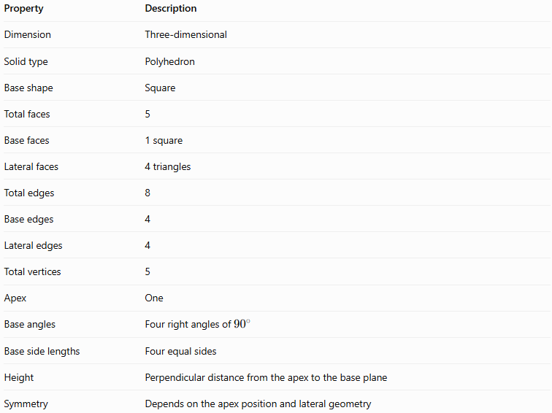
Property | Description
Dimension | Three-dimensional
Solid type | Polyhedron
Base shape | Square
Total faces | 5
Base faces | 1 square
Lateral faces | 4 triangles
Total edges | 8
Base edges | 4
Lateral edges | 4
Total vertices | 5
Apex | One
Base angles | Four right angles of ${90}^{∘}$
Base side lengths | Four equal sides
Height | Perpendicular distance from the apex to the base plane
Symmetry | Depends on the apex position and lateral geometry

Geometric Representation
# Source: AI Source: Provided by: [Data Path: Persons Table -> ID Column: 1, Name_En Column: Motasem Essam] -> From: [ChatGPT] on [7/25/2026]
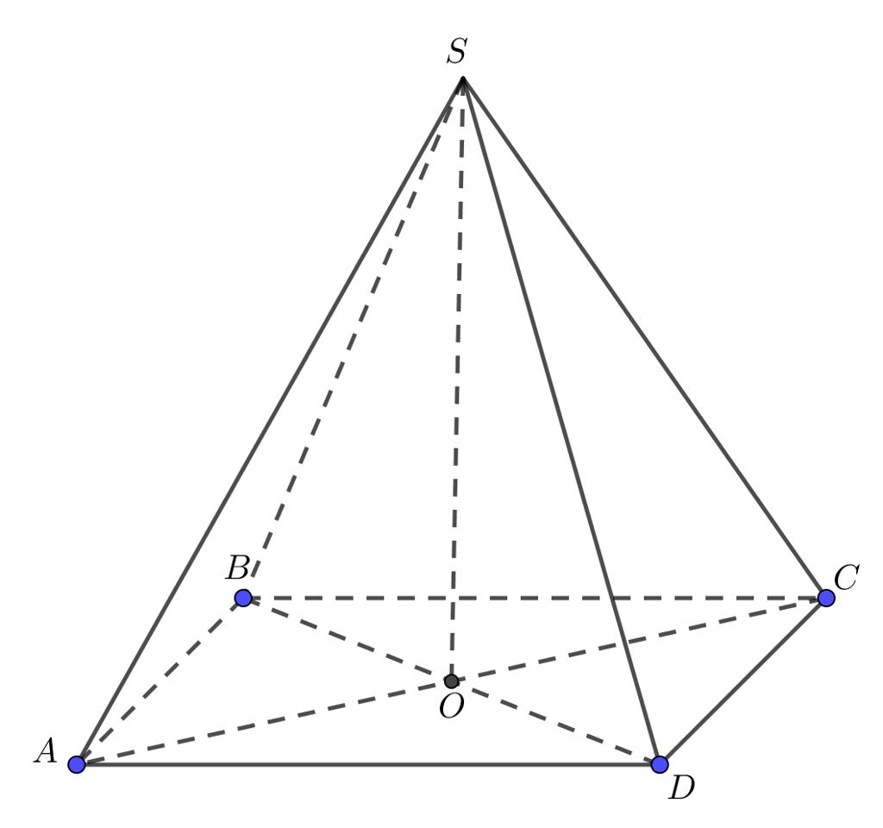
The main components of a square-base pyramid are:
- Square base $ABCD$: The bottom face, with four equal sides and four right angles.
- Apex $S$: The vertex where all four lateral faces meet.
- Base edges $AB$, $BC$, $CD$, and $DA$: The four edges surrounding the square base.
- Lateral edges $SA$, $SB$, $SC$, and $SD$: The four edges connecting the apex to the base vertices.
- Lateral faces $SAB$, $SBC$, $SCD$, and $SDA$: The four triangular side faces.
- Base center $O$: The center of the square, where its diagonals intersect.
- Perpendicular height $h$: The perpendicular distance from the apex to the plane of the square base.
- Slant height $l$: For a right square pyramid, the perpendicular distance along a lateral triangular face from the apex to the midpoint of a base edge.
The base is always square, but the lateral faces are not necessarily congruent unless the pyramid has the appropriate symmetry.

Mathematical Representations and Formulas
# Source: AI Source: Provided by: [Data Path: Persons Table -> ID Column: 1, Name_En Column: Motasem Essam] -> From: [ChatGPT] on [7/25/2026]
Let:
- $a$ = side length of the square base.
- $h$ = perpendicular height of the pyramid.
- $l$ = slant height, when a common slant height exists.
- $B$ = area of the base.
- $A_{L}$ = lateral surface area.
- $A_{T}$ = total surface area.
- $V$ = volume.

Base area and perimeter
# Source: AI Source: Provided by: [Data Path: Persons Table -> ID Column: 1, Name_En Column: Motasem Essam] -> From: [ChatGPT] on [7/25/2026]
Since the base is a square:
$$\boxed{B=a^{2}}$$
The base perimeter is:
$$\boxed{P_{b}=4a}$$
The base diagonal is:
$$\boxed{d=a\sqrt{2}}$$

Number of faces, edges, and vertices
# Source: AI Source: Provided by: [Data Path: Persons Table -> ID Column: 1, Name_En Column: Motasem Essam] -> From: [ChatGPT] on [7/25/2026]
For a pyramid with an $n$-sided base:
$$F=n+1, E=2n, V_{e}=n+1$$
For a square-base pyramid, $n=4$:
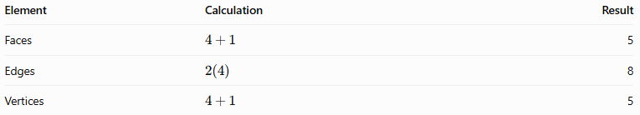
Element | Calculation | Result
Faces | $$4+1$$ | 5
Edges | $$2\left(4\right)$$ | 8
Vertices | $$4+1$$ | 5
Euler's formula for convex polyhedra is:
$$V_{e}-E+F=2$$
Substituting:
$$5-8+5=2$$
Therefore, the square-base pyramid satisfies Euler's formula.

Volume
# Source: AI Source: Provided by: [Data Path: Persons Table -> ID Column: 1, Name_En Column: Motasem Essam] -> From: [ChatGPT] on [7/25/2026]
The volume of any pyramid is one-third the base area multiplied by the perpendicular height:
$$V=\frac{1}{3}Bh$$
Since $B=a^{2}$:
$$\boxed{V=\frac{1}{3}a^{2}h}$$
This formula applies to both right and oblique square-base pyramids.

Lateral surface area
# Source: AI Source: Provided by: [Data Path: Persons Table -> ID Column: 1, Name_En Column: Motasem Essam] -> From: [ChatGPT] on [7/25/2026]
For a general square-base pyramid, calculate each triangular lateral face separately:
$$\boxed{A_{L}=A_{1}+A_{2}+A_{3}+A_{4}}$$
For a right square pyramid, all four lateral faces are congruent isosceles triangles and share the same slant height $l$. The area of one lateral face is:
$$A_{1}=\frac{1}{2}al$$
Therefore:
$$A_{L}=4\left(\frac{1}{2}al\right)$$
$$\boxed{A_{L}=2al}$$
Equivalently, using the base perimeter:
$$\boxed{A_{L}=\frac{1}{2}P_{b}l}$$
This simplified formula assumes a common slant height, as in a right square pyramid.

Total surface area
# Source: AI Source: Provided by: [Data Path: Persons Table -> ID Column: 1, Name_En Column: Motasem Essam] -> From: [ChatGPT] on [7/25/2026]
For a right square pyramid:
$$A_{T}=B+A_{L}$$
Therefore:
$$\boxed{A_{T}=a^{2}+2al}$$
For an oblique square-base pyramid, the general formula is:
$$\boxed{A_{T}=a^{2}+A_{1}+A_{2}+A_{3}+A_{4}}$$

Relationship between height and slant height
# Source: AI Source: Provided by: [Data Path: Persons Table -> ID Column: 1, Name_En Column: Motasem Essam] -> From: [ChatGPT] on [7/25/2026]
For a right square pyramid, the apex lies directly above the center of the square base. The distance from the base center to the midpoint of a side is $a/2$.
Using the Pythagorean theorem:
$$l^{2}=h^{2}+{\left(\frac{a}{2}\right)}^{2}$$
Thus:
$$\boxed{l=\sqrt{h^{2}+\frac{a^{2}}{4}}}$$
The lateral edge length $e$, from the apex to a base vertex, is different from the slant height:
$$e^{2}=h^{2}+{\left(\frac{a\sqrt{2}}{2}\right)}^{2}$$
Therefore:
$$\boxed{e=\sqrt{h^{2}+\frac{a^{2}}{2}}}$$

Worked Examples
# Source: AI Source: Provided by: [Data Path: Persons Table -> ID Column: 1, Name_En Column: Motasem Essam] -> From: [ChatGPT] on [7/25/2026]
Example 1: Calculating the base area and perimeter
A square-base pyramid has a base side length of $6\text{ cm}$.
Base area:
$$B=a^{2}=6^{2}$$
$$\boxed{B=36{\text{ cm}}^{2}}$$
Base perimeter:
$$P_{b}=4a=4\left(6\right)$$
$$\boxed{P_{b}=24\text{ cm}}$$
Example 2: Calculating volume
A square-base pyramid has a base side length of $8\text{ cm}$ and a perpendicular height of $9\text{ cm}$.
Using:
$$V=\frac{1}{3}a^{2}h$$
Substitute:
$$V=\frac{1}{3}\left(8^{2}\right)\left(9\right)$$
$$V=\frac{1}{3}\left(64\right)\left(9\right)$$
$$\boxed{V=192{\text{ cm}}^{3}}$$
Answer: The volume is $192{\text{ cm}}^{3}$.
Example 3: Calculating the surface area of a right square pyramid
A right square pyramid has a base side length of $10\text{ cm}$ and a slant height of $13\text{ cm}$.
Step 1: Calculate the base area.
$$B={10}^{2}=100{\text{ cm}}^{2}$$
Step 2: Calculate the lateral surface area.
$$A_{L}=2al$$
$$A_{L}=2\left(10\right)\left(13\right)=260{\text{ cm}}^{2}$$
Step 3: Calculate the total surface area.
$$A_{T}=100+260$$
$$\boxed{A_{T}=360{\text{ cm}}^{2}}$$
Answer: The total surface area is $360{\text{ cm}}^{2}$.

Comparison with Related Concepts
# Source: AI Source: Provided by: [Data Path: Persons Table -> ID Column: 1, Name_En Column: Motasem Essam] -> From: [ChatGPT] on [7/25/2026]
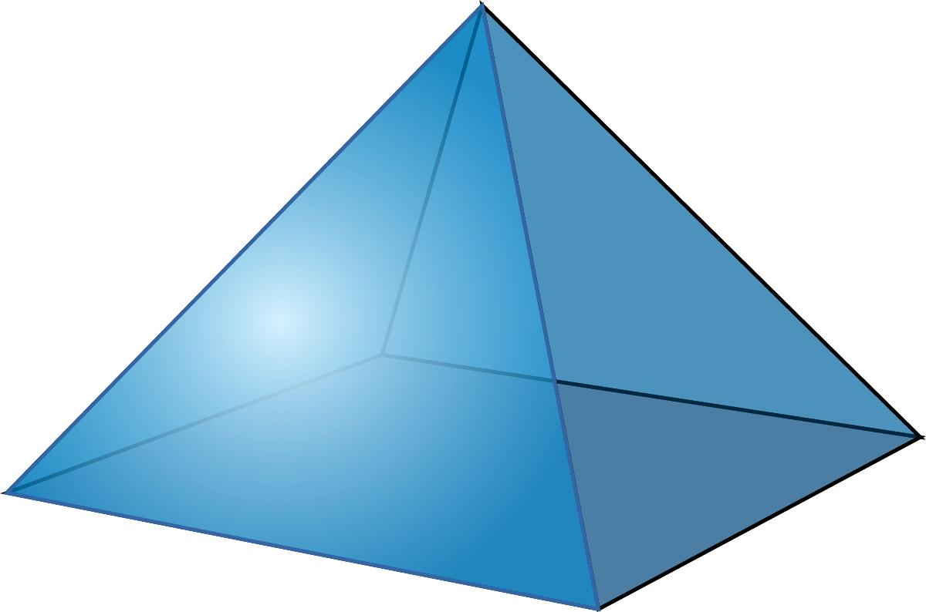
Square-Base Pyramid
Has one square base and four triangular lateral faces. Its apex can be positioned to create a right or oblique pyramid.
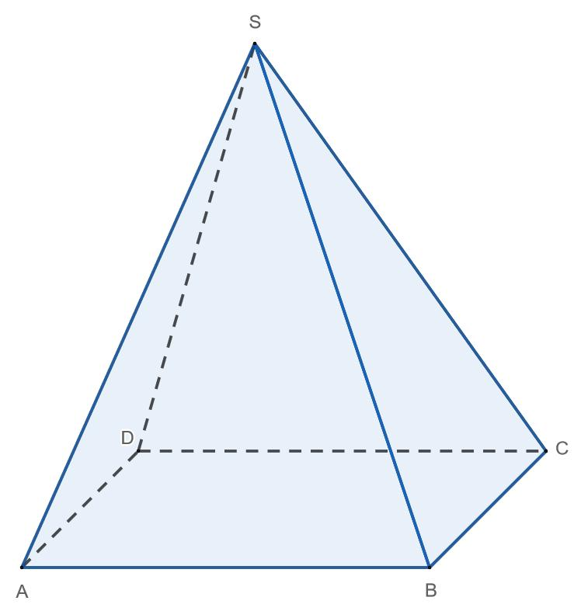
Rectangular-Base Pyramid
Has a rectangular base. Its base has two pairs of equal opposite sides, but adjacent sides are not necessarily equal.
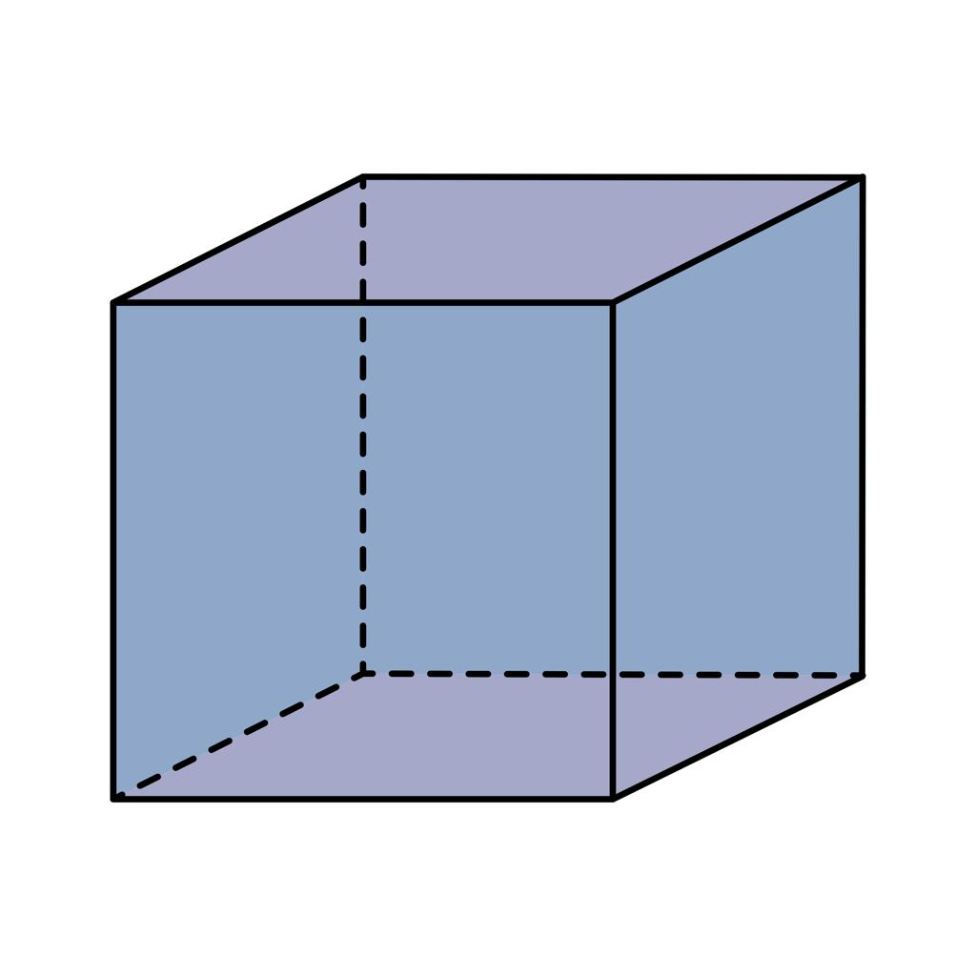
Square Prism
Has two parallel, congruent square bases and four lateral faces that are parallelograms. Unlike a pyramid, it has no single apex.
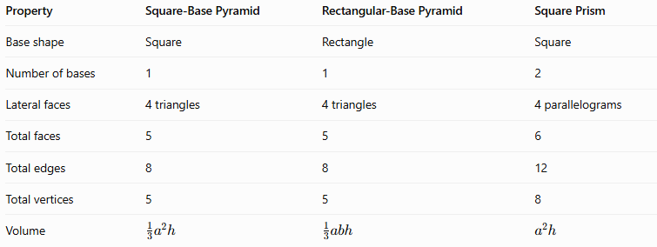
Property | Square-Base Pyramid | Rectangular-Base Pyramid | Square Prism
Base shape | Square | Rectangle | Square
Number of bases | 1 | 1 | 2
Lateral faces | 4 triangles | 4 triangles | 4 parallelograms
Total faces | 5 | 5 | 6
Total edges | 8 | 8 | 12
Total vertices | 5 | 5 | 8
Volume | $$\frac{1}{3}a^{2}h$$ | $$\frac{1}{3}abh$$ | $$a^{2}h$$
In the rectangular-base pyramid formula, $a$ and $b$ are the rectangle's side lengths.

Constructing Square-Base Pyramid in Solid Geometry

Instruments Used
# Source: AI Source: Provided by: [Data Path: Persons Table -> ID Column: 1, Name_En Column: Motasem Essam] -> From: [ChatGPT] on [7/25/2026]
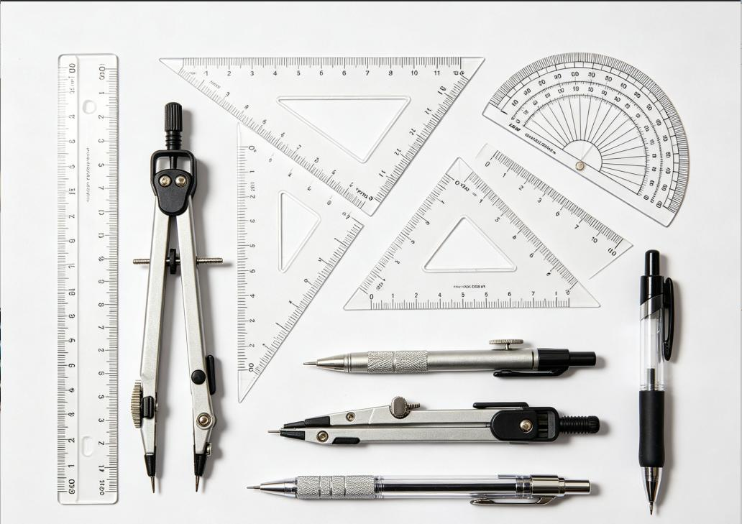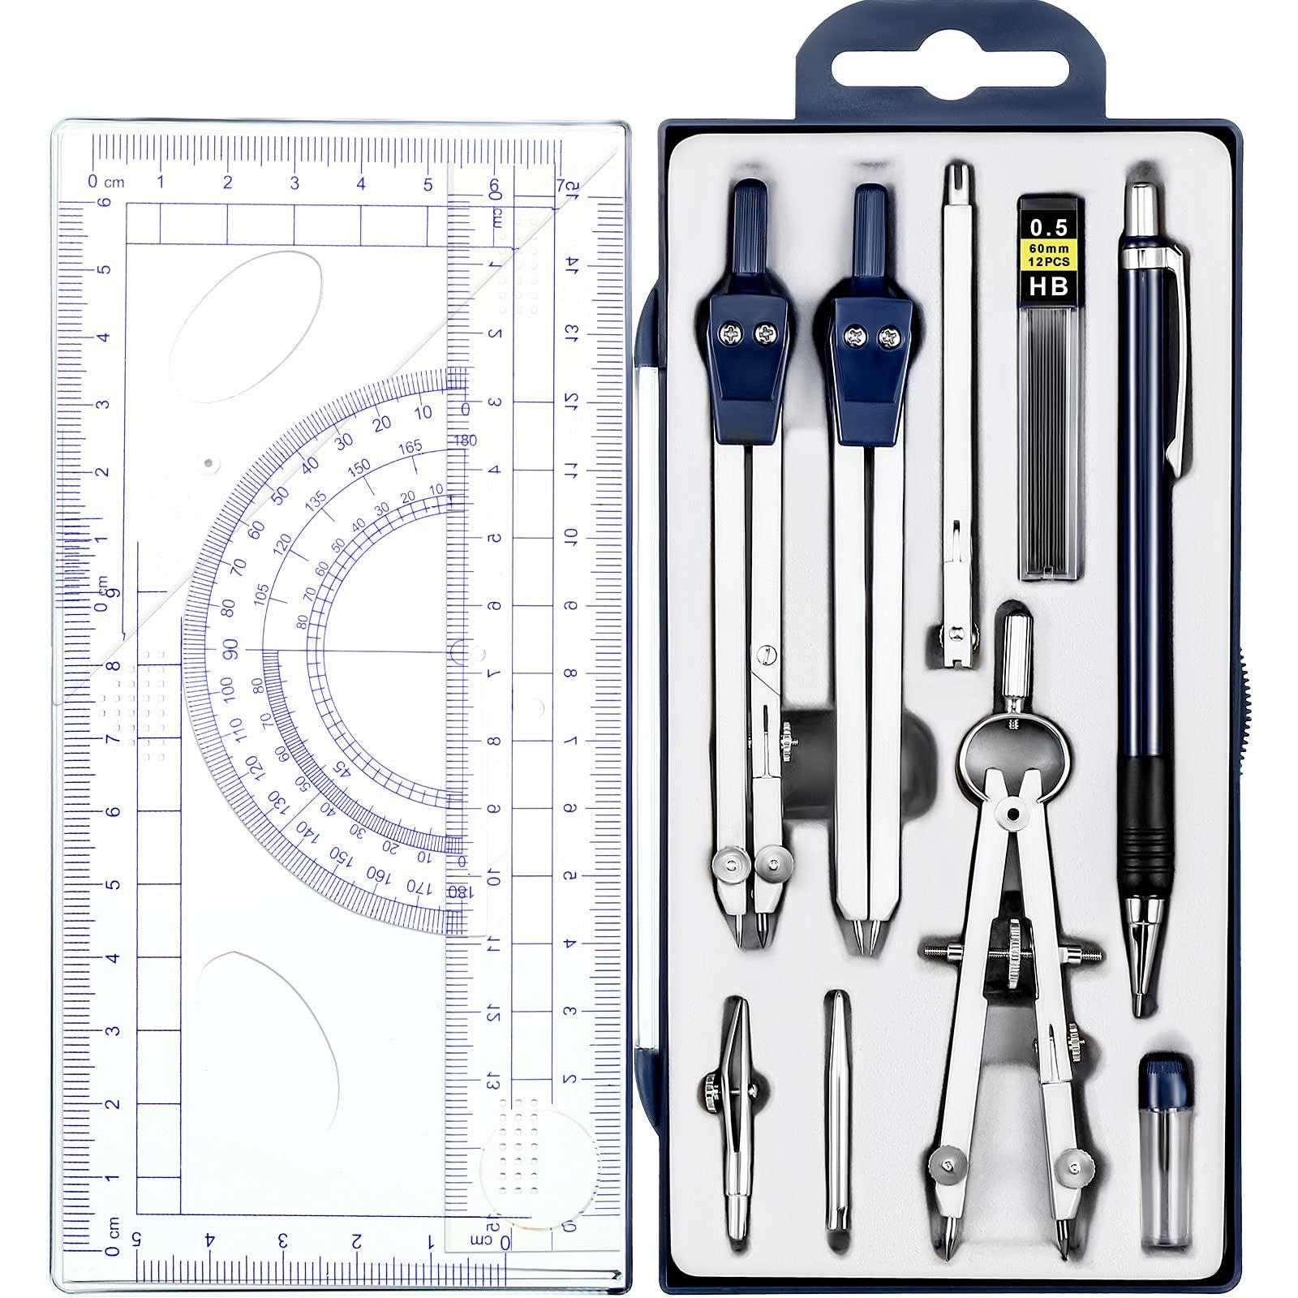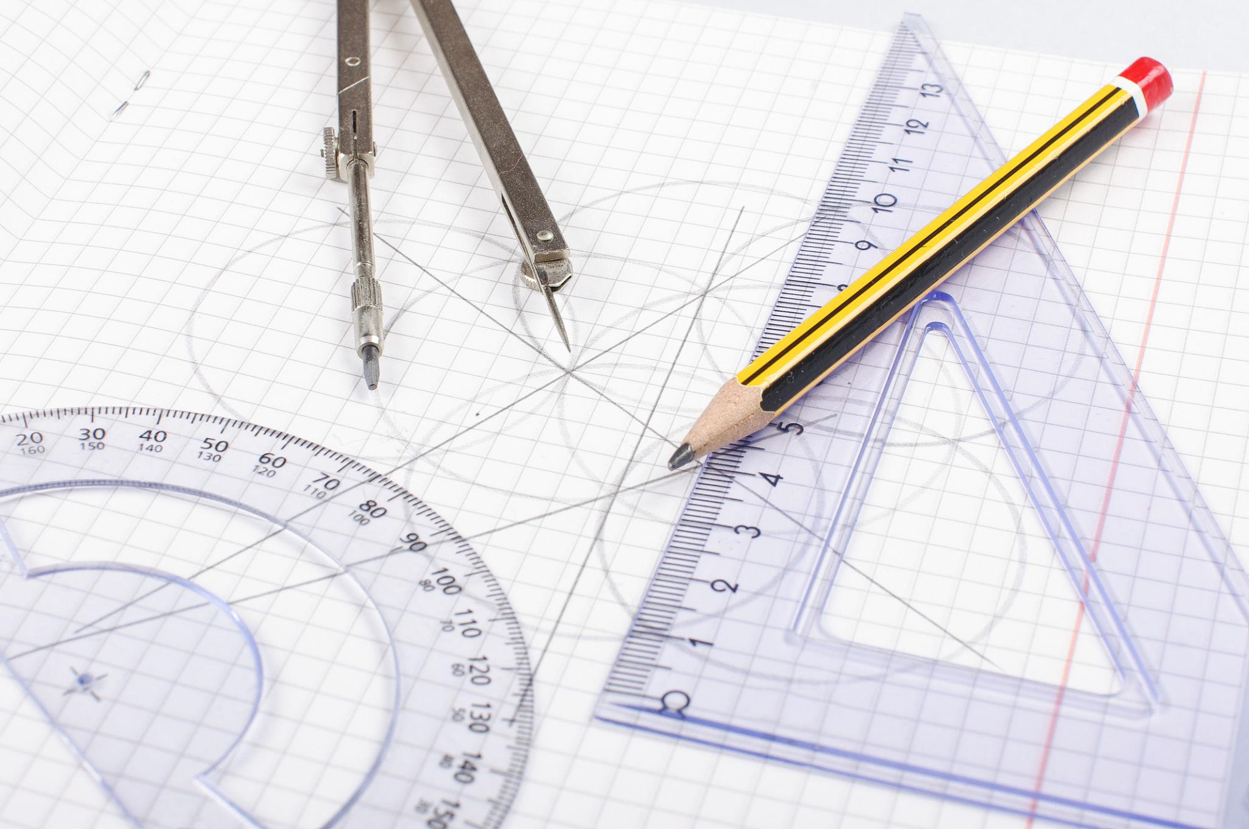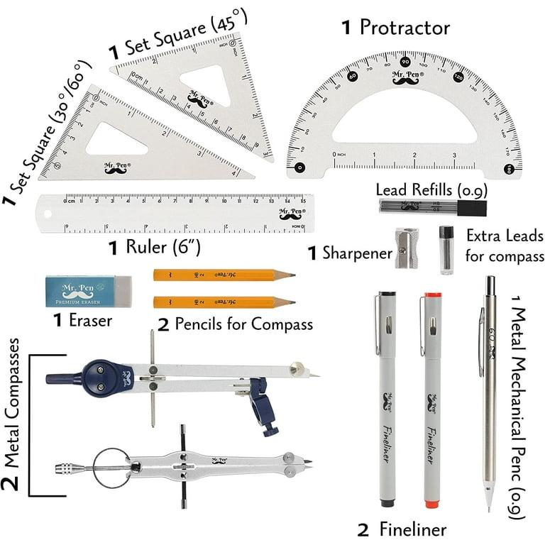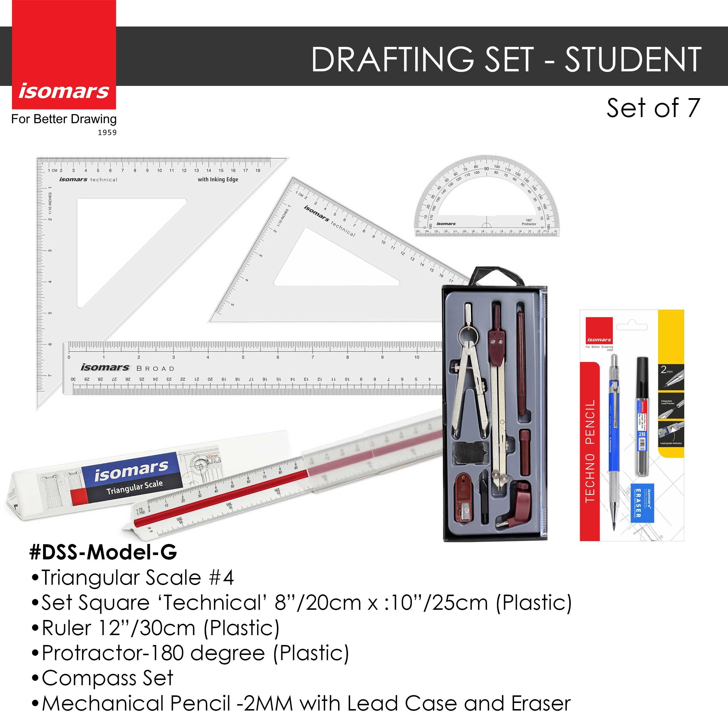
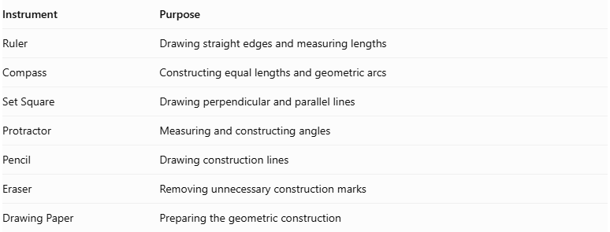
Instrument | Purpose
Ruler | Drawing straight edges and measuring lengths
Compass | Constructing equal lengths and geometric arcs
Set Square | Drawing perpendicular and parallel lines
Protractor | Measuring and constructing angles
Pencil | Drawing construction lines
Eraser | Removing unnecessary construction marks
Drawing Paper | Preparing the geometric construction
Construction Method: Instrument-Based

Construction Procedures

Constructing the Square Base
# Source: AI Source: Provided by: [Data Path: Persons Table -> ID Column: 1, Name_En Column: Motasem Essam] -> From: [ChatGPT] on [7/25/2026]
- Draw a straight base side using a ruler.
- Construct perpendicular lines at its endpoints using a set square.
- Mark equal side lengths on the perpendicular lines.
- Connect the remaining endpoints to complete the square.
- Label the four base vertices.

Constructing a Right Square-Base Pyramid
# Source: AI Source: Provided by: [Data Path: Persons Table -> ID Column: 1, Name_En Column: Motasem Essam] -> From: [ChatGPT] on [7/25/2026]
- Construct the square base.
- Draw the diagonals of the square to locate its center.
- Draw a perpendicular line through the center of the base.
- Mark the desired perpendicular height on this line.
- Label the endpoint as the apex.
- Connect the apex to all four base vertices.
- Draw visible edges using solid lines.
- Draw hidden edges using dashed lines where appropriate.
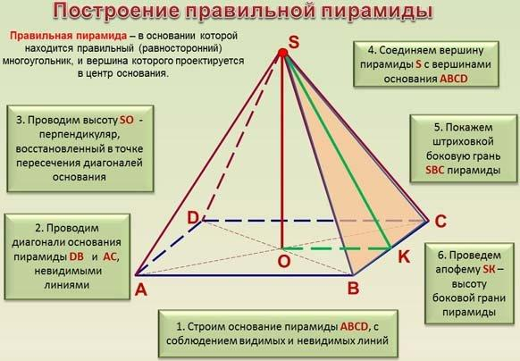

Constructing an Oblique Square-Base Pyramid
# Source: AI Source: Provided by: [Data Path: Persons Table -> ID Column: 1, Name_En Column: Motasem Essam] -> From: [ChatGPT] on [7/25/2026]
- Construct the square base.
- Select an apex position that is not directly above the center of the square.
- Draw the apex above the base plane.
- Connect the apex to all four base vertices.
- Distinguish visible and hidden edges.
- Verify that the lateral faces are triangular.
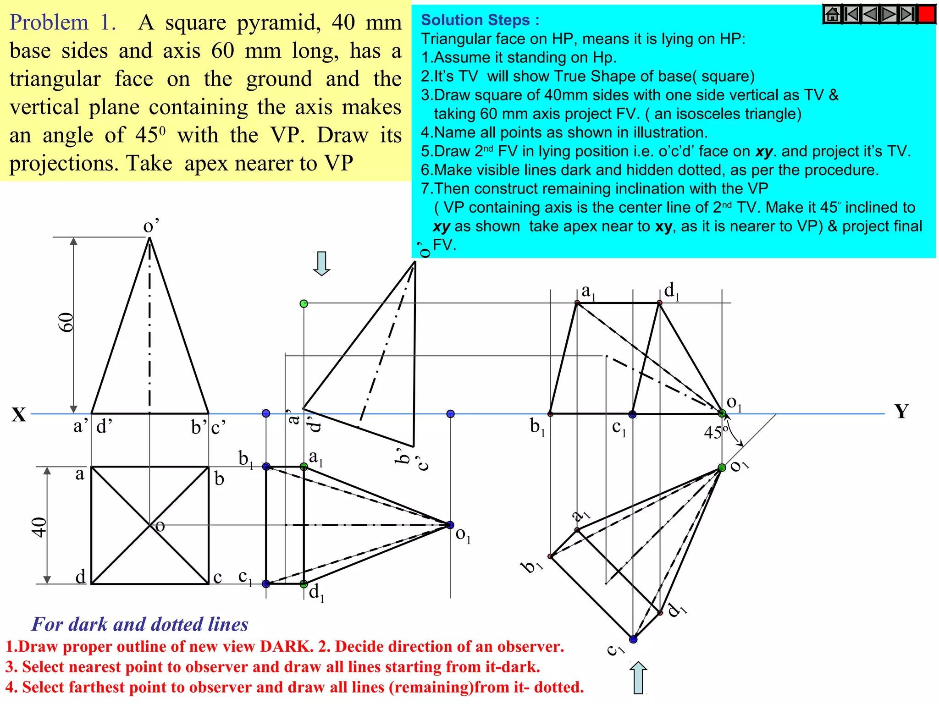

Constructing the Net of a Square-Base Pyramid
# Source: AI Source: Provided by: [Data Path: Persons Table -> ID Column: 1, Name_En Column: Motasem Essam] -> From: [ChatGPT] on [7/25/2026]
- Draw one square representing the base.
- Construct four triangular faces, one attached to each side of the square.
- Ensure that the triangular side lengths correspond to the pyramid's lateral edges.
- Add joining flaps if the net is intended for physical assembly.
- Cut and fold the net to form the pyramid.
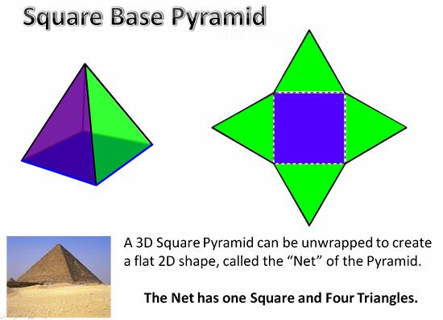

Applications
# Source: AI Source: Provided by: [Data Path: Persons Table -> ID Column: 1, Name_En Column: Motasem Essam] -> From: [ChatGPT] on [7/25/2026]
- Architecture: Pyramid-shaped roofs and decorative structures.
- Ancient construction: The square-base pyramid form is used in famous monumental structures such as the Egyptian pyramids.
- Engineering: Modeling tapered components and structural forms.
- Computer graphics: Constructing three-dimensional objects from polygonal faces.
- Mathematics education: Studying surface area, volume, symmetry, and the relationship between two-dimensional bases and three-dimensional solids.

Key Points
# Source: AI Source: Provided by: [Data Path: Persons Table -> ID Column: 1, Name_En Column: Motasem Essam] -> From: [ChatGPT] on [7/25/2026]
- A square-base pyramid is a type of quadrilateral pyramid.
- It has one square base and four triangular lateral faces.
- It has 5 faces, 8 edges, and 5 vertices.
- The base area is $a^{2}$, and the base perimeter is $4a$.
- The volume is $\frac{1}{3}a^{2}h$.
- For a right square pyramid, the lateral surface area is $2al$.
- For a right square pyramid, the total surface area is $a^{2}+2al$.
- The perpendicular height and slant height are different measurements.
- The simplified surface-area formulas require the common slant height found in a right square pyramid.

Conclusion
# Source: AI Source: Provided by: [Data Path: Persons Table -> ID Column: 1, Name_En Column: Motasem Essam] -> From: [ChatGPT] on [7/25/2026]
A square-base pyramid is a polyhedron with a square base and four triangular lateral faces meeting at a single apex. It has five faces, eight edges, and five vertices. Its defining feature is its square base, while the position of the apex determines whether the pyramid is right or oblique.
Its volume is calculated using one-third of the square base area multiplied by the perpendicular height. Its surface area is found by adding the base area to the areas of the four lateral triangles. Understanding square-base pyramids provides a foundation for studying other quadrilateral pyramids and comparing pyramids with prisms.

